

**CMSC 495 6380**

**USER GUIDE**

### GROUP 7

Franklin Pokam

Ayodeji Onitilo

Arnaud Tako

REVISION HISTORY TABLE

|  |  |  |
| --- | --- | --- |
| DATE | NAME | DESCRIPTION |
| 07/07/2022 | Ayodeji Onitilo | System Requirements, Installation, Operations |
| 07/11/2022 | Franklin Pokam | This week i worked on, MySQL tables, Java source code. I ran the code. Wrote the background. I also wrote the user’s guide |
|  |  |  |
|  |  |  |
|  |  |  |

**User’s Guide**

# Background

A library management system is being developed by Group 4 in CMSC495. The application will utilize user and admin accounts with different privileges and functionalities for both types of accounts. Users will be allowed to borrow or return library books and to check their account status for late fees. This information will be displayed in a graphic user interface that allows the user or admin to query, view and edit account status.

# System Requirements

* A personal computer with JDK 6.0.
* Windows 10 is used as the operating system.
* MySQL is used as the database.
* Development tool and programing language: java 8 was used to produce the entirety of the source code.
* Intel Core i5 was used as the processor.
* Only 1 GB of RAM is needed for memory capability.
* NetBeans IDE 8.2 was used (My computer is old).

# Installation

The message needs to run java 8 and NetBeans 8.2, as well as the recent version of MySQL

The following link provides the steps to installing NetBeans in your machine:

[How to Install NetBeans IDE 8.2 on Windows (notesformsc.org)](https://notesformsc.org/install-netbeans-ide-8-2-windows/)

The steps are as follow:

We start our installation by downloading the latest version of NetBeans IDE 8.2. Visit the site http://netbeans.org to download it.

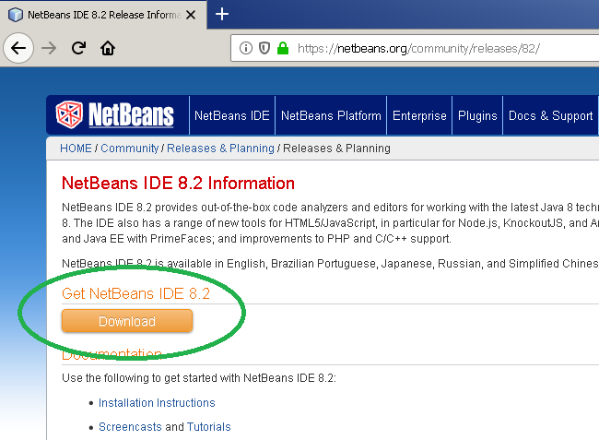Download NetBeans

When you click on the download option, it will take you to the download page. You can download any package suitable for your computer, but for the sake of this tutorial, download the full version.

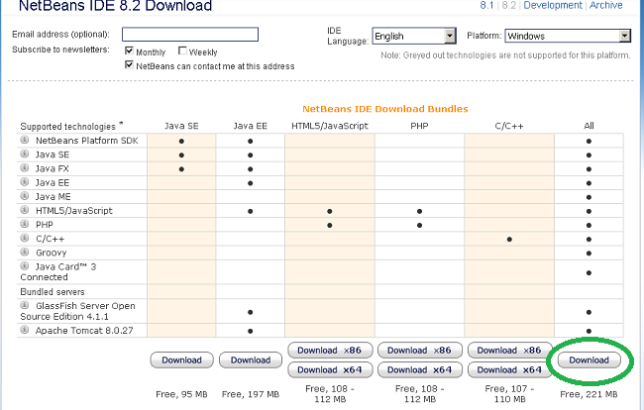Download Full version

The full version contains most of the packages. Now, create a new folder NetBeans and download the software.

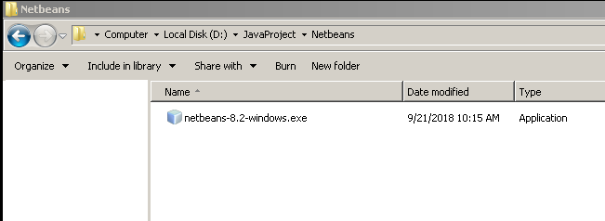Netbeans setup file

You cannot run the setup immediately before you run setup to make sure that the Java JDK 10.0.2 is installed correctly.

Sometimes, you may receive an error when you start the setup. The screenshot for error is shown below.

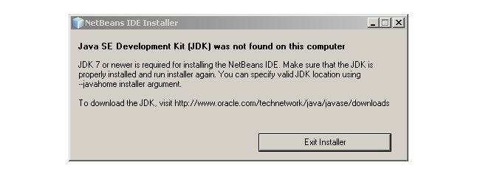Netbeans Setup error

We have Java JDK installed, but you may still get this message. To solve this problem, download and install Java JDK 8u111 update from the Oracle site.

1. **Download and Install JDK 8u111 Update**

Once downloaded JDK 8u111 updates, you can begin the installation.

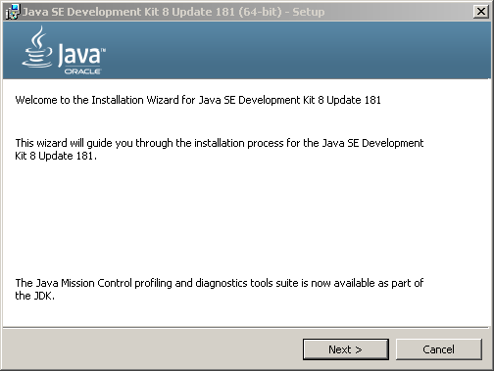JDK 8u111 updates installation

Click next to continue with the installation.

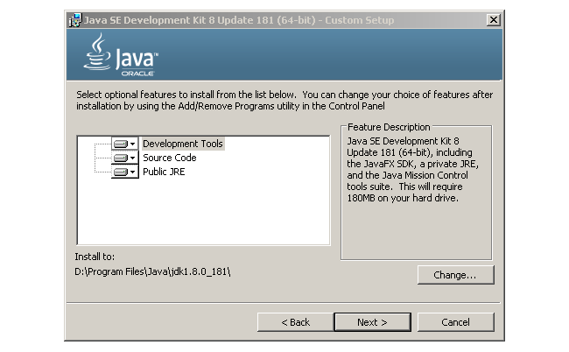Custom Setup

The custom setup window will show, here you can change the default installation directory if required. Click next to continue installation.

Advertisement

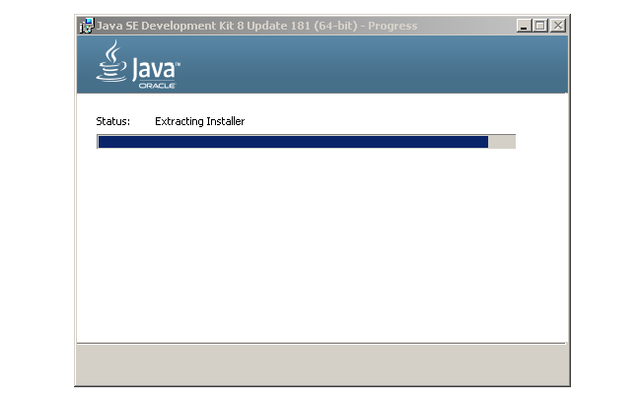Setup Prepares the Installer Wizard

The JDK setup prepares an installer for further installation. The installer also requests a custom destination for installation.

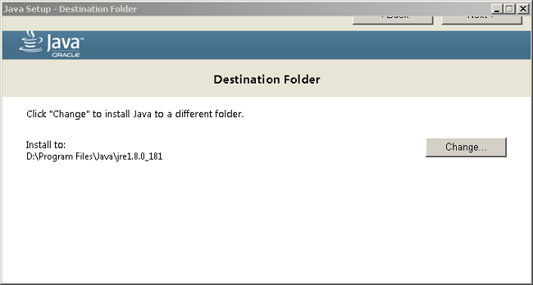Installer Custom Setup

Click next on the top to continue.

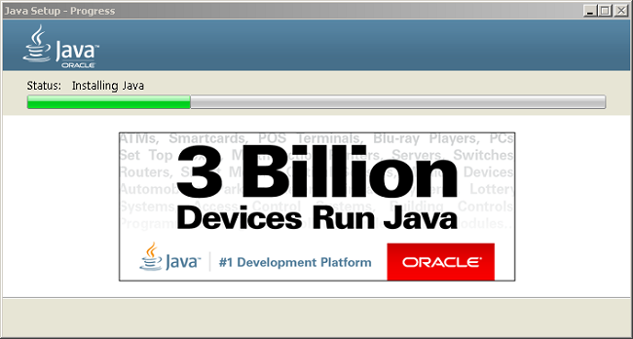Installing JDK 8

Once the installation begins it takes few minutes to complete the setup.

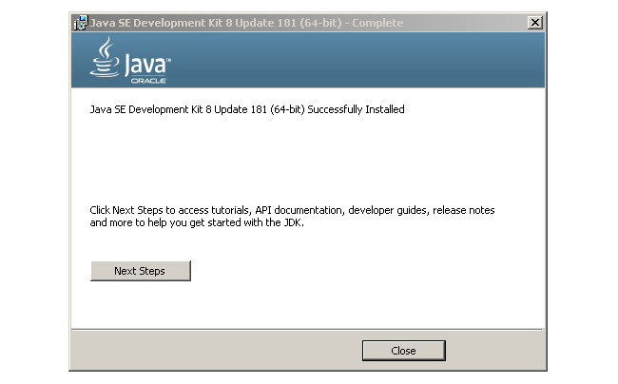Setup Completes

Close the window when installation is finished.

1. **Install NetBeans IDE 8.2**

With all prerequisites in place, you can begin installing NetBeans IDE 8.2. Double click the setup again.

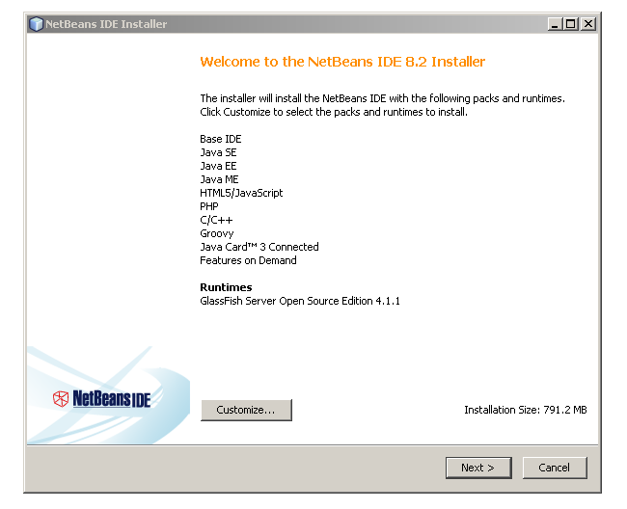NetBeans 8.2 Setup

This the screen where you can customize, by choosing what to install. Click on next to continue.

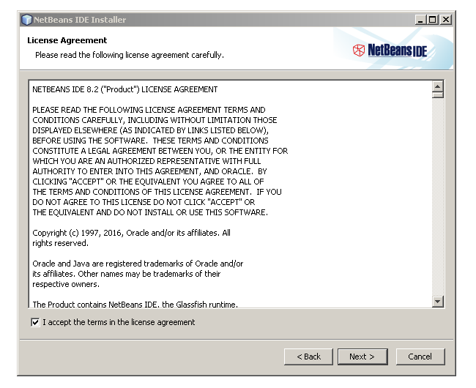Agree to the License agreement

Put a check on “I accept the terms in the license agreement” after you have read the license agreement. Click next to continue with the setup.

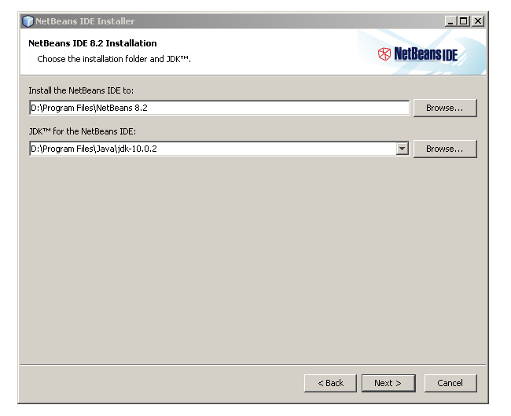Change Installation Directory

Advertisement

On the next screen, you get an option to change the installation directory. You can change the location of the installation if a specific drive does not have enough space.

Click next to continue otherwise.

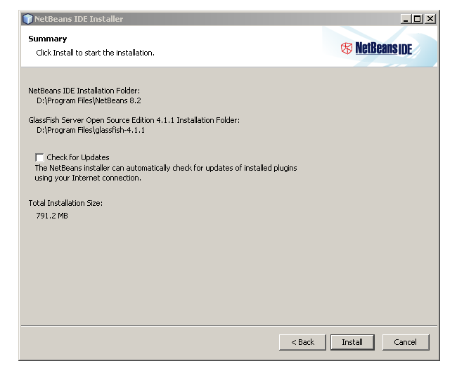Before starting installation read Summary page

A summary of all options is given on the next screen, review them before clicking Install.

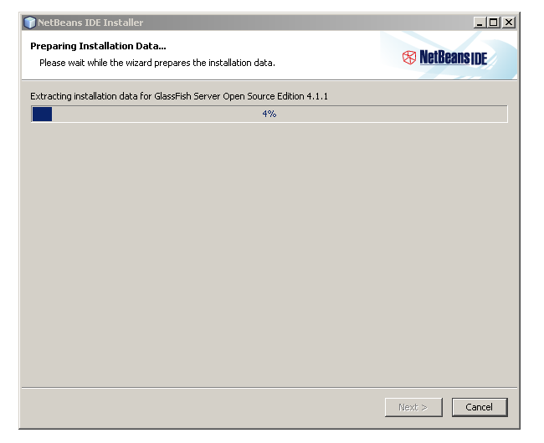Installation continues

The installation may take some time depending on the speed of your computer.

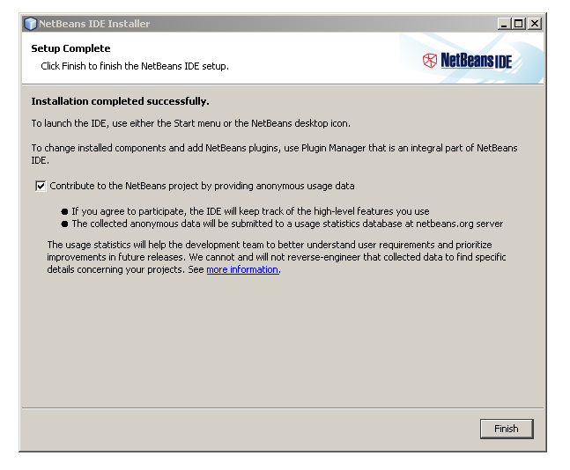Installation Completes

After the installation completes click on Finish to complete the setup process.

After the download is complete, you need to connect the java application with MYSQL using NetBeans. The steps to do can be find by clicking on the following link:

[How to connect Java application with MySQL using NetBeans (geekinsta.com)](https://www.geekinsta.com/how-to-connect-java-application-with-mysql-using-netbeans/)

1. **Downloading MySQL JDBC driver**

* To download the latest version of the JDBC driver, visit [this link](https://dev.mysql.com/downloads/connector/j/). From **Select Operating System** drop-down, select **Platform Independent** and download the zip archive.
* Extract and open the downloaded file. There will be a file named mysql-connector-java-8.0.12.jar (version number may be different).

1. **Setting-up database**

* Start xampp.
* Turn on Apache and MySQL.
* Create a MySQL database. The MySQL database we created was **p2p_library.**

1. **Configuring the NetBeans project**

* Open NetBeans and create a new project by clicking **File->New Project**.
* From the Choose Project window, select **Java->Java Application** and click next.
* Choose a project name and click Finish: **p2p_Library.java**
* Expand the project folder and Right-click on Libraries.
* Select Add **JAR/Folder**.
* Select **mysql-connector-java-8.0.12.jar** and click open. Now you will see the jar file listed under *Libraries*.
* Go to **Window->Services**.
* Right-click on **Databases** and select **New Connection**.
* Click Add and select mysql*-connector-java-8.0.12.jar* file. From Driver drop-down, select **MySQL (Connector/J driver)**. Click Next.
* In the Customize Connection window, replace the **Database** name with the one you have created for the application. If you have not created a database, leave it as it is.
* Click **Test Connection**.

Creating database tables

* We used the web browser to navigate to [localhost / 127.0.0.1 | phpMyAdmin 4.7.9](http://localhost/phpmyadmin/)
* We used a text file to write down the necessary tables, then we pasted the file in the database query page, and we click on go. The tables were added to p2p-library database.

These are the tables:

Library user table

Library transaction table

Library member table

Library book table

Library book category

**Operation: Running the Library Management System**

Now that the database contains tables, and the source code is ready, and the application is connected to MySQL, you shall run it on NetBeans by clicking run.

* 1. **User Login:**

The login page shall appear.

The user shall enter the username and password that were created in the database.

Login page

Failed login attempt

When verified credentials are entered, the application opens its main page.

Main page

* 1. **Administrator Functions/Registering new member**
* The user shall click on admin, and then click on change password to change the administrator password.
* The user shall also click on user master to check or change the status of other users.
* The user shall then click on new to add a new member.
* The user shall click on user type to select whether the new user is an administrator or a student.
* The user shall click on next to view the next user in the database.
* You The user shall click on edit to edit a member’s detail.
* The user shall click on save to save the register the new member, or to save the edits.
* The user shall click on close to exit the admin master page.

Only users to admin privileges have access to this page.

Image showing the change password GUI

Image showing the active status of a member

Image showing a successfully update of a member’s details

* 1. **Search Book**
* The user shall click on book and then search book to launch its GUI.
* The user shall then enter either the book ID, keyword, or title.

Image showing a successful search using just the book’s title.

* 1. **Update Books**
* The user shall check, and update the book status by click on book, then book status from the drop-down menu.
* The user shall click on refresh status to see the list of available books.
* The user shall change the availability of a book by writing either available or unavailable in the appropriate column, and by clicking refresh status to confirm the change.

List of available books

Book 5 has been changed from available to unavailable

* 1. **Add Books**

The user shall click on book, and from the drop-down menu, click on book master to edit the details of a book, add a new book, or delete a book from the database.

GUI to add a new book.

Image showing message displayed when attempting to save a new book without entering book details

* The user shall click on save to finish editing or adding a book record.
* The user shall click on close to close out the GUI.

Image showing the successful addition of a book.

* 1. **Add Users**
* The user shall click on member to manage non-administrator members: students.
* The user shall click on add, then from the drop-down menu, click member master to either add a member or edit a member’s information.

Image showing the GUI to add a member

Image showing the successful addition or edit of a member.

Image showing missing information when adding a member

* 1. **Search users**
* The user shall click on member, then from the drop-down menu, click on search member to search ha member.
* The user shall search a member by using either the name of the member, the id number of the member, or the telephone number of the member.

Image showing the search member GUI

Successful search of a member by using just the id number

* The user shall click on transaction, to issue books, return books, and access a transaction report.
* The user shall click on transaction, and then from the drop-down menu, click on issue book to issue a book to a student.
* The user shall then enter the member id of the person the book is being issued to, and click details to see whether or not the book can be issued to that member.
* If successful, the user shall enter the book id and click on issue book to rent out the book to the member.
* The user shall also click on reset to reset the page.
* The user shall click on close the close the page.

Book issue page

Adding member id and book id to issue book

Book issued successfully

Book already issued

When entering a non-existing member

* 1. **Return Book**
* The user shall return books from member by clicking on transaction, and then from the drop-down menu, click on receive books.
* The Return books GUI shall appear.
* The user shall enter the id number of the member returning the book and click on details. The list of borrowed books shall appear, and you shall receive the book by clicking on receive books.

Return book page

After entering the member id number and clicking details, the book being returned appears

Book returned successfully

Member didn’t check out a book– the receive book button isn’t activated

Invalid member – cannot return a book

* 1. **Transaction Record**
* The user shall click on transaction to view the transaction report
* The user shall click on transaction, then on refresh report to view every single transaction to date.

Transaction page

Transaction report

